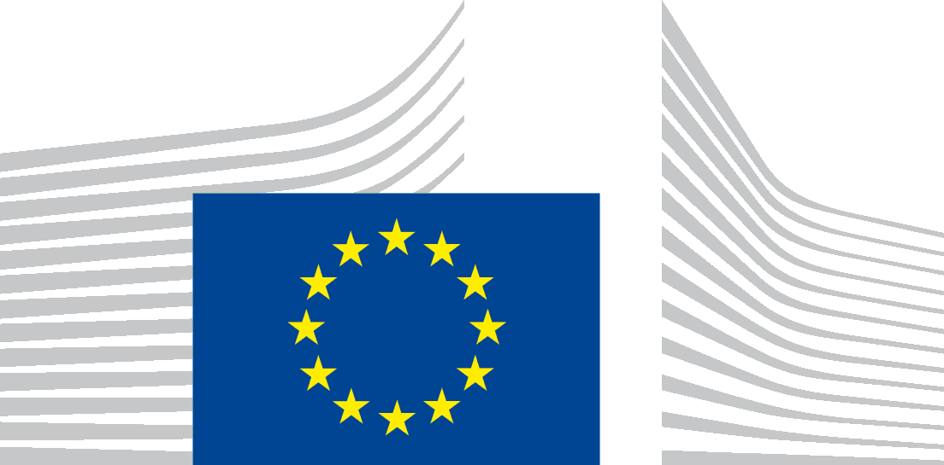 | EUROPEAN COMMISSION
VACANCY NOTICE FOR A POST OF SECONDED NATIONAL EXPERT
DG – Directorate – Unit | Unit F.3 – Global Environmental Cooperation and Multilateralism
Post number in sysper: | 287683
Contact person:  Provisional starting date:  Initial duration:  Place of secondment: | Cristina DE AVILA  2nd quarter of 2025  2 years  ☒ Brussels ☐ Luxemburg ☐ Other: Click or tap here to enter text.
 | ☐ With allowances ☒ Cost-free
This vacancy notice is open to:
☒ EU Member States
☐ EFTA-EEA In-Kind agreement (Iceland, Liechtenstein, Norway)
This vacancy notice is also open to:
☒ The following EFTA countries:
☒ Iceland ☒ Liechtenstein ☒ Norway ☐ Switzerland
☐ The following third countries:
☐ The following intergovernmental organisations:
Deadline for applications | ☒ 2 months ☐ 1 month

Entity Presentation (We are)
The expert will work in the "Global Environmental Cooperation and Multilateralism" Unit of DG Environment (ENV.F.3), which deals with multilateral environmental agreements, global biodiversity policy, wildlife trade and conservation, access to genetic resources, desertification, and relations with UN Environment Programme.

Job Presentation (We propose)
The expert will contribute to several files for which the International Biodiversity Team is responsible, to be decided in the light of needs of the team and the expertise and preferences of the candidate. This may include, inter alia, the following:
- Multilateral work related to forests, notably preparing the EU contribution and participation in meetings of the United Nations Forum on Forests (UNFF), the International Timber Trade Organisation (ITTO), and the Committee on Forestry of the UN Food and Agriculture Organization (FAO COFO);
- Work on access to genetic resources and the fair and equitable sharing of benefits arising from their utilisation (ABS), including work at global level under the Convention on Biological Diversity and the Nagoya Protocol, as well as work at EU level, notably the implementation and upcoming evaluation of the EU ABS Regulation;
- Work on specific topics addressed under the Convention on Biological Diversity.
The expert will be involved in the drafting of briefing material and will frequently interact with other Services in the European Commission, EU Member States and external stakeholders. He/she will participate in relevant Council Working Party and inter-service coordination meetings, in meetings with the Member States’ Competent Authorities, and in bilateral and multilateral international negotiations.

Jobholder Profile (We look for)
The ideal candidate has a scientific or policy background relevant to environmental policy and international relations and/or relevant professional experience in the field of environmental policy and international relations.
We look for a well-organised colleague with a sense of initiative, excellent written and oral communication skills, good negotiation skills (preferably also at international level), and able to work in a team. The ability to draft legal texts would be an advantage.
The person we are looking for should be willing to travel.
While the main working language of the Unit is English, excellent knowledge of which is required, good knowledge of other EU or UN languages would be an advantage.

Eligibility criteria
The secondment will be governed by the Commission Decision C(2008) 6866 of 12/11/2008 laying down rules on the secondment to the Commission of national experts and national experts in professional training (SNE Decision).
Under the terms of the SNE Decision, a national expert needs to comply with the following eligibility criteria at the starting date of the secondment:
Professional experience: at least three years of professional experience in administrative, legal, scientific, technical, advisory or supervisory functions which are equivalent to those of function group AD.
Seniority: having worked for at least one full year (12 months) with the current employer on a permanent or contract basis.
Employer: must be a national, regional or local administration or an intergovernmental public organisation (IGO); exceptionally and following a specific derogation, the Commission may accept applications where the employer is a public sector body (e.g., an agency or regulatory institute), university or independent research institute.
Linguistic skills: thorough knowledge of one of the EU languages and a satisfactory knowledge of another EU language to the extent necessary for the performance of the duties. The national expert from a third country must produce evidence of a thorough knowledge of the EU language necessary for the performance of his duties.

Conditions of secondment
During the full duration of the secondment, the national expert remains employed and remunerated by his / her employer and covered by his / her (national) social security system.
He / she shall exercise his / her duties within the Commission under the conditions as set out by aforementioned SNE Decision and be subject to the rules on confidentiality, loyalty and absence of conflict of interest as defined therein.
Allowances can only be granted when the national expert fulfils the conditions provided for in Article 17 of the SNE decision.
Staff posted in a European Union Delegation are required to have a security clearance (up to SECRET UE/EU SECRET level according to Commission Decision (EU, Euratom) 2015/444 of 13 March 2015. The selected candidate has the obligation to launch the vetting procedure before getting the secondment confirmation.

Submission of applications and selection procedure
Candidates should send their application according to the Europass CV format (Create your Europass CV | Europass) in English, French or German only to the Permanent Representation / Diplomatic Mission to the EU of their country, which will forward it to the competent services of the Commission within the deadline fixed by the latter. The CV must mention the date of birth and the nationality of the candidate.
Candidates are asked not to add any other documents (such as copy of passport, copy of degrees or certificate of professional experience, etc.). If necessary, these will be requested at a later stage.

Processing of personal data
The Commission will ensure that candidates’ personal data are processed as required by Regulation (EU) 2018/1725 of the European Parliament and of the Council (). This applies in particular to the confidentiality and security of such data. Before applying, please read the attached privacy statement.

() Regulation (EU) 2018/1725 of the European Parliament and of the Council of 23 October 2018 on the protection of natural persons with regard to the processing of personal data by the Union institutions, bodies, offices and agencies and on the free movement of such data, and repealing Regulation (EC) No 45/2001 and Decision No 1247/2002/EC (OJ L 295, 21.11.2018, p. 39

